Lab 4

The Intelligence of the Computer

Description: This lab provides a good hands on approach to set up a computer with the software intelligence necessary for doing the functions we have learned to expect and maybe love (I am a sucker for romance even if it is with a computer). This software content is called the operating system (OS for short). Using a well known operating system called Windows 7, we will explore what is involved in its installation and some useful tools it provides us. When you have completed this lab you will be able to answer the following questions in the Observations and Conclusions section of your final lab report.
- Having no OS on my hard drive can my system boot from an external CD? If not what do I need to do?
- Having an OS already on my hard drive can my system boot from an external CD? If not what do I need to do?
- What does partitioning a drive do?
- Am I limited to only one operating system per computer?
- What is the product key?
- What is a computer administrator?
- How much space does an operating system take up?
- How can I ascertain the internals of my computer system without opening it up? What else can I learn from the keyboard?

Procedure

1. Mark down computer provided
vendor __________________
model # _________________

2. Power up the computer. There should be no system password, but if one is accidentally present (we don’t pay our technicians enough), we certainly know how to bypass it (you guys are getting dangerous).
…………….
3. Does the system boot up with Windows 7? Yes ____ No____

4. If not, a Windows 7 CD will be provided to install the operating system on the hard drive.
If yes, we will still provide a Windows 7 to reinstall the operating system on the hard drive. Let us assume the one presently booting is corrupted and needs to be removed. Anything is possible with what our technicians set up. They just don’t get paid enough.

5. Insert the provided Windows 7 CD in the proper drive tray with the shiny side down and reboot. Does the system start to prompt you to boot from the CD?
Yes ____ No____
6. If not we need to change the boot sequence for the CD Rom device to be first. Restart the system again. As soon as the system has started, hit the F12 key a number of times (or whichever key you are prompted to hit). This should take you to the boot set up menu. The boot menu provides the user with choices. Now select the CD to boot from.

7. We are now ready for Windows 7 (Waiting for Gidot). During the following installation of the Windows 7 operating system there is some wait time. During this time we have provided for your enjoyment and pleasure some digital exercises for you to complete for this lab. They are shown at the end of this document. Have fun!

8. Press any key to boot from CD and enter the Windows setup. The installer program will begin copying files from the CD.

9. Once the initialization process completes, you will see "Install Windows" screen with three options. For clean install, select NEXT.

10. Click INSTALL NOW. You should see “Setup is starting…”

11. Select the X64 bit (second option) operating system. Click NEXT.
12. Agree to the licensing agreement and NEXT.

13. Select second option: Custom Installation.

14. Click on the second partition. Click on the Drive options (advanced). Click on Delete and OK to remove the partition. Do the same for the first partition.
15. The system is now ready for the procedure of partitioning and formatting. Partitioning sets up the physical drive into numerous logical drives if space allows it. Click on New, Apply and OK. Two new partitions will be created. Partitioning also allows for multiple OS. Many users have both MS Windows and the open source Linux (Everyone is allowed to contribute to this OS without being paid).

16. Click Next, and Windows 7 will begin to install.

17. While installing the following questions need to be answered (Personal Info).
Name: Harry
Click Next

18. Password: Press enter
Confirm password: Press enter
Click NEXT

21. Now enter the product key which is on the CD ROM (vendors wants their money, no counterfeits allowed) provided incorrectly first.
Computer response _______________________

22. Enter the product key correctly
.
23. Choose User Recommended Settings

26. Pass by and view date and time. Change if incorrect.

27. Network settings: Skip

28. After installation fill in below
- Left click the start tab (lower left corner of the monitor) and right click Computer and select Properties.
Select computer name: ____________________
- Go to Control Panel. Select user accounts
Computer Administrator: ____________________

35. With the user in Windows 7 (finally!) we need to use some of the OS’s capability to learn what is happening to our system.

- Start/Computer

How many hard drives? _________
Drive C free space _______________
Drive C total capacity _____________

b. Start/ right Click Computer/ Properties
Find processor and clock speed ___________________________________________
Total Physical Memory ____________________________

c. Task Manager – Right click on bottom bar and choose Task Manager
(or simultaneously hit all three keys: control-alt-delete)
The Task Manager is a powerful tool that gives you a picture of what your computer is doing at this moment in time. I must digress and say, “aren’t computers lucky.” We would love to have indicators that tell us how efficient our body is running, what its condition is and where there is a problem.
Okay, continuing with the lab, let us open up the editor program notepad.
Start> programs> accessories> notepad
Back to the task manager one should see there are a number of tabs.
Select Performance and provide the following
CPU Usage _____________

Commit Charge (K) gives the amount of memory in the system being used for running programs. This includes physical plus disc space used (virtual memory).
Total.___________

Switch to Applications tab. Record the info you see for Notepad
Task ______________________
Status _____________________

Switch to Process tab. Record the following info you see for an open windows of Notepad.
Name _____________________________________
CPU % _____________
Memory Usage (physical ram) __________________
Now minimize Notepad window. Check again the following.
Memory Usage ______________________________
Was there any difference? Hmm
What if your system was running very slowly. Would the process tab page help out?
I guess another hmm.
Now suppose Notepad was hanging up. The user could not shut it down. We could the go to the application tab, select Notepad and click end task. Do this now for Notepad
Notepad ended? ____________.
The Process tab page would also work but you would need to know which .exe program is responsible for the application acting up. Not always easy to determine that.

Exercises

Convert the following
- 110₂ = ______₁₀
- 11₂ = ______₁₀
- 1100₂ = ______₁₀
- What principal(s) about binary math did you
discover from examples 1 to 3? _____________________________________

- 1000000000₂ = ________ ₁₀
- 14₁₀ = ___________ ₂
- 64₁₀ = ___________ ₂
- 255₁₀ = __________ ₂
- 110₂ = ______₁₆
- 10₂ = ______₁₆
- 1100₂ = ______₁₆
- 1000000000₂ = ________ ₁₆
- 11111111₂ = ________ ₁₆
- How does example 8 relate to example 13
- 4 meg = _______ k
- 4 k = ________ meg
- 1700 meg = ________ gig
- Write the word “A 2/8 cut” in extended ascii hex ______________
- (1100₂) and (1010)₂ = ___________ ₂
- (1100₂) or (1010)₂ = ___________ ₂

Reference http://www.cdrummond.qc.ca/cegep/informat/Professeurs/Alain/files/ascii.htm

Author: H. Schanker Rev E 1/2/2018

Table ASCII -I
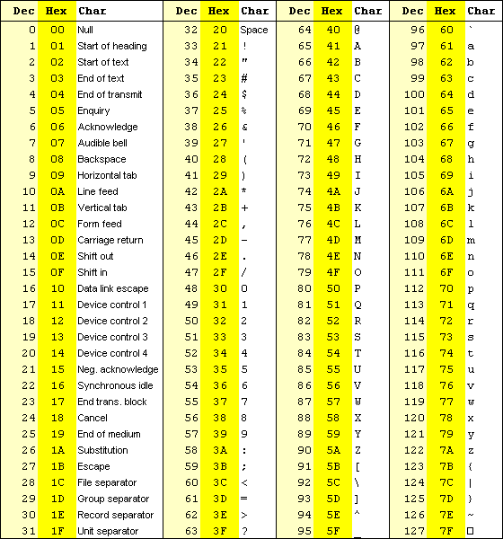

Lab4 (Continued)
TABLE ASCII -II
