IMPORTANT SAFETY NOTE: Shut Power means remove power chord from outlet

Description: This lab provides an introductory understanding of how the pieces of a computer fit and work together. The elements of a computer, both hardware and software, work in an extremely harmonious manner to accomplish amazing tasks and functions. We will explore and discover how this happens. When you have completed this lab you will be able to answer at a minimum the following questions in the Observations and Conclusions section of your final lab report.

- Where do I connect the various Input/Output devices to my system unit?
- What are some of my computer’s internal devices and how do they tie together?
- What is the BIOS and its functions?
- What is the connection and difference between the BIOS and CMOS?
- Is the BIOS independent of the operating system (OS)?
- How do I detect visual problems without video feedback?

Procedure

1. Mark down computer provided:
vendor __________________
model # _________________

2. At the back of your computer there are a number of connectors. On Figure 1 below all of them are indicated with numbers. Fill in the numbers 1, 4, 5, 6, 7, 8, 9, and 10 in Table 1 next to the space of the connector description or where the mentioned device might plug in.
Figure 1 Back Panel Connectors
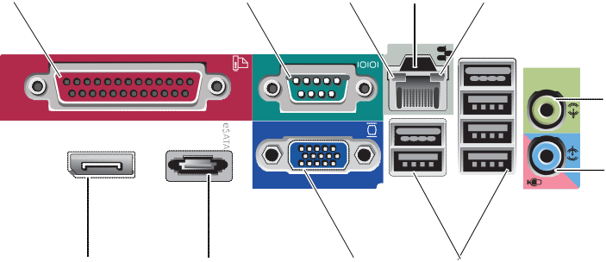
1
2
3
4
5
11
10
9
8

Table 1 Labels for Figure 1
__ | parallel connector | __ | network connector connector
__3 | link integrity light |  | line-out connector
__ | network-activity light | __ | eSATA connector
 | line-in connector | 2__ | serial connector
__ | VGA video connector | __ | USB 2.0 connectors (6)
11 | DisplayPort connector | __
__________

3. Connect keyboard, mouse, monitor, and power cord to the computer. Remember any respectable computer must be able to do input and output. If not then it will only have brains and be considered a nerd. On the other hand, someday it could become a very rich nerd.

4. (Tables below are from http://downloads.dell.com/manuals/all-products/esuprt_desktop/esuprt_optiplex_desktop/optiplex-760_service%20manual_en-us.pdf)
Now turn power on to both the computer and monitor. Since we have no money you probably have a defective machine. (What do you expect? 8th generation 32+GB?) Anyway, the computer should provide some diagnostics to help out. They include a sequence of beeps, a possible error message (visible on screen only if display components not affected) and a front panel that includes 4 diagnostic lights shown vertically. When you hear a sequence of beeps listen for sets of beeps. (Please note that each set is separated by a longer pause.) Mark down the beep sequence with the time spacing indicated, as for example 3-2-1.
beep sequence _________________
monitor display (error message?) _________________________
diagnostic light colors (4 LEDs separated by commas starting top to bottom.
e.g. (Off,GREEN,Off,Off ) _____________________________________

Table 2 Beep codes
Code | Cause
2 short, 1 long | BIOS checksum error
1 long, 3 short, 2 short | Memory error
1 short | F12 key pressed

Table 3 Resolutions for beep codes
Code (repetitive short beeps) | Description | Suggested Resolution
1 | BIOS checksum failure. Possible system board failure. | Contact Dell (see Contacting Dell).
2 | No memory modules are detected. | If two or more memory modules are installed, remove the modules, then reinstall one module and restart the computer. If the computer starts normally, continue to install additional memory modules (one at a time) until you have identified a faulty module or reinstalled all modules without error. See Memory.  If available, install working memory of the same type into your computer. See Memory.  If the problem persists, contact Dell (see Contacting Dell).
3 | Possible system board failure. | Contact Dell (see Contacting Dell).
4 | RAM Read/Write failure. | Ensure that no special requirements for memory module/connector placement exist. See Memory.  Ensure that the memory you are using is supported by your computer. See Memory.  If the problem persists, contact Dell (see Contacting Dell).
5 | Real time clock failure. Possible battery or system board failure. | Replace the battery. See Replacing the Battery.  If the problem persists, contact Dell (see Contacting Dell).
6 | Video BIOS Test Failure. | Contact Dell (see Contacting Dell).

Table 4 Diagnostic lights during POST

Light Pattern | Problem Description | Suggested Resolution
Off | The computer is either turned off or not receiving power. | Reseat the power cable in the power connector on the back of the computer and the electrical outlet.  Bypass power strips, power extension cables, and other power protection devices to verify that the computer turns on properly.  Ensure that any power strips being used are plugged into an electrical outlet and are turned on.  Ensure that the electrical outlet is working by testing it with another device, such as a lamp.  Ensure that the main power cable and front panel cable are securely connected to the system board.
Off | A possible motherboard failure has occurred. | Unplug the computer. Allow a minute for the power to drain. Plug the computer into a working electrical outlet and press the power button.  If the problem persists, contact Dell (see Contacting Dell).
Blinking Amber | A possible motherboard, power supply, or peripheral failure has occurred. | Power off computer, leaving the computer plugged in. Press and hold the power supply test button on the back of the power supply unit.  If the power supply diagnostic light next to the switch illuminates, the problem may be with your system board. Contact Dell (see Contacting Dell).  If the power supply diagnostic light next to the switch does not illuminate, disconnect all internal and external peripherals, and press and hold the power supply test button.If it illuminates, there could be a problem with a peripheral. Contact Dell (see Contacting Dell).  If the power supply diagnostic light still does not illuminate, disconnect the power supply from the system board, then press and hold the power supply button.  If the light illuminates, there could be a problem with the system board.  If the power supply diagnostic light still does not illuminate, the problem is probably with the power supply.  Contact Dell (see Contacting Dell).
Steady Amber | No CPU present. | Reinstall the processor and restart the system. If the computer still fails to boot, inspect the processor socket for damage.  If the problem persists, contact Dell (see Contacting Dell).
Steady Amber | Memory modules are detected, but a memory power failure has occurred. | If two or more memory modules are installed, remove the modules, then reinstall one module and restart the computer.  If the computer starts normally, continue to install additional memory modules (one at a time) until you have identified a faulty module or reinstalled all modules without error.  If only one memory module is installed, try moving it to a different DIMM connector and restart the computer.  If available, install verified working memory of the same type into your computer.  If the problem persists, contact Dell (see Contacting Dell).
 | A possible CPU or motherboard failure has occurred. | Replace the processor with a known good processor. If the computer still fails to boot, inspect the processor socket for damage.  If the problem persists, contact Dell (see Contacting Dell).

Steady Amber
Steady Amber | BIOS may be corrupt or missing. | The computer hardware is operating normally but the BIOS may be corrupt or missing. Contact Dell (see Contacting Dell).
Steady Amber | A possible motherboard failure has occurred. | Remove all cards from the PCI and PCI-E slots and restart the computer. If the computer boots, add the cards back one by one until you find the bad one.  If the problem persists, the system board may be faulty. Contact Dell (see Contacting Dell).
Steady Amber | Power connector not installed properly. | Reseat the 2x2 power connector from the power supply unit.  If the computer still fails to boot, contact Dell (see Contacting Dell).
Steady Amber | Possible peripheral card or motherboard failure has occurred. | Remove all cards from the PCI and PCI-E slots and restart the computer. If the computer boots, add the cards back one by one until you find the faulty one.  If the problem persists, the system board is probably bad. Contact Dell (see Contacting Dell).
Steady Amber | A possible motherboard failure has occurred. | Disconnect all internal and external peripherals, and restart the computer. If the computer boots, add the peripheral back one by one until you find the faulty one. Contacting Dell.  If the problem persists, the system board is probably bad. Contact Dell (see Contacting Dell).
Steady Amber | A possible coin cell battery failure has occurred. | Remove the coin cell battery for one minute, reinstall the battery, and restart.  If the problem persists, contact Dell (see Contacting Dell).
Steady Green | The computer is in a normal on  condition.  The diagnostic lights are not lit after the computer successfully boots to the operating system. | Ensure that the display is connected and powered on.  If the problem persists, contact Dell (see Contacting Dell).
Steady Green | A possible processor failure has occurred. | Reseat the processor (see Processor information for your computer).  If the problem persists, contact Dell (see Contacting Dell).
 | Memory modules are detected, but a memory failure has occurred. | If two or more memory modules are installed, remove the modules and then reinstall one module (see Memory).  Restart the computer. If the computer starts normally, continue to install additional memory modules (one at a time) until you have identified a faulty module or reinstalled all modules without error.

Steady Green |  | If available, install working memory of the same type into your computer (see Memory).  If the problem persists, contact Dell (see Contacting Dell).
Steady Green | A possible graphics card failure has occurred. | Reseat any installed graphics cards (see the "Cards" section for your computer).  If available, install a working graphics card into your computer.  If the problem persists, contact Dell (see Contacting Dell).
Steady Green | A possible floppy drive or hard drive failure has occurred. | Reseat all power and data cables.
Steady Green | A possible USB failure has occurred. | Reinstall all USB devices and check all cable connections.
Steady Green | No memory modules are detected. | If two or more memory modules are installed, remove the modules (see Removing Memory Module (s)), then reinstall one module (see Installing Memory Module (s)) and restart the computer.  If the computer starts normally, continue to install additional memory modules (one at a time) until you have identified a faulty module or reinstalled all modules without error.  If available, install working memory of the same type into your computer (see Memory).  If the problem persists, contact Dell (see Contacting Dell).
Steady Green | Memory modules are detected, but a memory configuration or compatibility error has occurred. | Ensure that no special requirements for memory module/connector placement exist.  Ensure that the memory you are using is supported by your computer (see the Setup and Quick Reference Guide that ships with your computer).  If the problem persists, contact Dell (see Contacting Dell).
Steady Green | A possible expansion card failure has occurred. | Determine if a conflict exists by removing an expansion card (not a graphics card) and restarting the computer (see the "Cards" section for your computer).  If the problem persists, reinstall the card you removed, then remove a different card and restart the computer.  Repeat this process for each expansion card installed. If the computer starts normally, troubleshoot the last card removed from the computer for resource conflicts.  If the problem persists, contact Dell (see Contacting Dell).
Steady Green | Another failure has occurred. | Ensure that all hard drive and optical drive cables are properly connected to the system board (see the "System Board Components" section for your computer).  If there is an error message on the screen identifying a problem with a device (such as the floppy drive or hard drive), check the device to make sure it is functioning properly.  If the operating system is attempting to boot from a device (such as the floppy drive or optical drive), check system setup to ensure the boot sequence is correct for the devices installed on your computer.  If the problem persists, contact Dell (see Contacting Dell).
Blinking Green | The computer is in standby mode. | Press a key on the keyboard, move the mouse, or press the power button to resume normal operation.

5. In order to repair this problem review diagnostic indications in Table 2, Table 3, and Table 4 above.

6. Did you find it?
Note problem discovered: ______________________________

7. Let us see what is causing it.

CAUTION: Before you begin any of the procedures in this section, follow the safety instructions . To avoid electrical shock, always unplug your computer from the electrical outlet before removing the computer cover.

Power down and open up computer (see Figure 2 below).

8. Check problem on the big circuit board called the motherboard (system board). (What happened to the father board? As Rodney Dangerfield says “we get no respect”).
What’s wrong? _______________________________
Now fix the problem. We are not going to pay you for doing nothing. Oh, we are not paying you guys anyway!

Figure 2 Opening Computer
Removing the Computer Cover

WARNING: To guard against electrical shock, always unplug your computer from the electrical outlet before removing the computer cover.

- Follow the procedures in Working on Your Computer.

- If you have installed a padlock through the padlock ring on the back panel, remove the padlock.

- Slide the release latch back as you lift the cover.

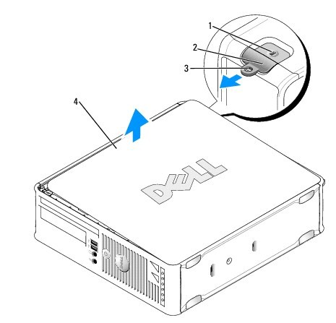

1 | security cable slot | 2 | cover release latch
3 | padlock ring | 4 | computer cover

- Pivot the cover up using the bottom hinges as leverage points.

- Remove the cover from the hinge tabs and set it aside on a soft nonabrasive surface.

NOTICE: Be careful when opening the computer cover to ensure that you do not accidentally disconnect cables from the system board

9. Now that you are inside the computer (not every on is invited to look inside ). From info provided figure out and fill in the numbers on the blank descriptions in Table 5 of the internal computer chassis items shown in Figure 3.

Figure 3 System Board components
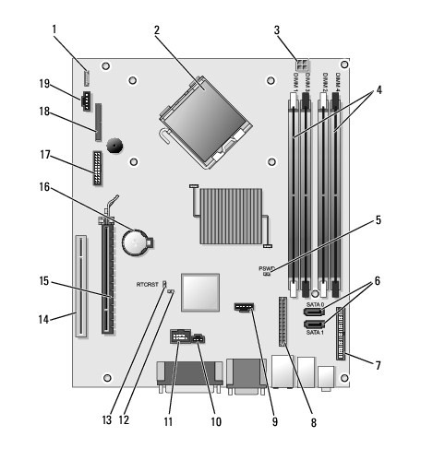

Table 5 System Board components
 | password jumper (PSWD) | 11 | internal USB (INT_USB)
 | processor power connector (12VPOWER) | 16 | PCI connector (SLOT2, SLOT3)
10 | intrusion switch connector (INTRUDER) | 13 | RTC reset jumper (RTCRST)
 | processor connector (CPU) | 18 | PS/2 or serial connector (SERIAL2)
9 | SATA drive connectors (SATA2 and SATA3) | 20 | fan (FAN_CPU)
 | front-panel connector (FRONTPANEL) |  | battery socket (BATTERY)
 | SATA drive connectors (SATA0 and SATA1) | 14 | PCI Express x16 connector (SLOT1)
19 | floppy connector (DSKT) |  | memory module connectors (DIMM_1, DIMM_2, DIMM_3, and DIMM_4)
12 | service mode disable jumper |  | power connector (POWER)
15 | PCI Express x1 connector (SLOT4) | 1 | internal speaker (INT_SPKR)

10. Read the internal power supply specs. In this country the input power in watts is equal to 120 volts times amps drawn. The output is the DC watts. Answer the following:

maximum dc output in watts __________________
maximum input current at 120 volts __________
maximum input watts _____________
efficiency of supply in % ___________
What do you think of this efficiency?

11. Working with an opened up computer turn power on. . Error beeps should not exist. If not go back to solving problem.
Problem solved _______________________

12. If problem is solved system password is now probably being requested. We don’t have much but we are a proud department who protects their equipment. So there are two options. Get the password from the instructor (unlikely too mean; better chance with the technician) or bypass it.
Since you are now in the computer world you do what is in fashion. We will bypass (disable it) and then have it changed.

13. Turn off power and carefully (we are always very polite) remove system jumper shown in figure 5. Do not lose jumper but place in a very safe spot. Your grade depends on this.

14. Power up again and see if system password has been disabled. Check off below when password requirement has been removed.
No password required ____________

15. Well we can’t leave the system in this state. We need to introduce our own passwords for both the system and the BIOS setup. Power down and reinstall the system jumper (I told you not to lose it).
Reinserted system jumper? _____________

16. We now want to reintroduce a new system password. To do this function we need to enter the BIOS setup. Of course to get to the BIOS you would key in something at the start up time. Try function key F2.

17. Power up again and key in the above found key(s) just at start up time to enter the BIOS setup. Select
a. System Security and enter
b. Admin Password and enter
c. Provide new password enter
New Admin Password (of course we want to know)_______________

18. Entering the system booting can also require a password. As before in 17, install a system password.
System booting password __________________

19. Now we need to test our change. Repower the system and call over your professor or the technician to check the workings of your new system setup and booting passwords. What do you think we don’t trust you guys changing the password correctly? Yes!
Instructor or tech’s initials ____________________

20. We are now going to get some info from our BIOS. Record the following settings.

Space for settings

System Time __________________________
System Date __________________________
Memory Info
Installed System Memory ________________
Memory Speed ________________________
CPU Info
Bus Speed_______________________________
PROC
Processor Speed __________________________
SATA-0 __________________________________
SATA-1 __________________________________

21. Do we see the physical drives that our BIOS indicate we have? (Remember the words of wisdom that seeing is believing and never trust a used car salesman or do I mean a used computer) Yes or No _________
If no what drives are missing or extra? ____________

That’s all folks. The End

Reference Links:
http://downloads.dell.com/manuals/all-products/esuprt_desktop/esuprt_optiplex_desktop/optiplex-760_setup%20guide_en-us.pdf
http://downloads.dell.com/manuals/all-products/esuprt_desktop/esuprt_optiplex_desktop/optiplex-760_service%20manual_en-us.pdf​

